CS3009 - Software Engineering
Employee Management System
Final Project Report
Sprints 1, 2 & 3 — Complete System Documentation

Team Members
Muhammad Faheem | Irtaza Kazmi | Humayun Bilal

1. Introduction
The Employee Management System (EMS) is a Java desktop application built with JavaFX and SQLite to automate common HR activities. The project was delivered across three sprints. Sprint 1 established the core foundation: authentication, role-based access control, department setup, employee lifecycle management, and deactivation request handling. Sprint 2 extended the system with leave management, attendance tracking, and employee search. Sprint 3 completed the product by delivering payroll processing, document management, role-specific dashboards, and department deletion controls — resulting in a complete end-to-end business management system with role-aware boundaries.

2. Project Vision
The project vision is to provide a secure and integrated HR management platform that supports three distinct user roles: Administrator, Manager, and Employee. Refined through all three sprints, the vision emphasizes operational automation, department-level control, and decision support:
- Automate HR operations across attendance, leave, employee lifecycle, payroll, and documents.
- Enforce role-based data boundaries (Administrator, Manager, Employee).
- Provide reliable, actionable dashboards for organizational monitoring.
- Reduce manual paperwork and improve record traceability.
- Deliver a maintainable desktop system suitable for local organizational deployment.

3. Intended Use of the System

3.1 Who Will Use the System
- Administrator: manages top-level organizational setup, approval authority, and financial operations.
- Manager: handles department-scoped employee operations, approvals, and document review.
- Employee: uses self-service features for attendance, leave, documents, and payroll history.
- Secondary stakeholders: HR, Finance, IT Support, and Organizational Management.

3.2 How the System Is Used
- Users authenticate with a username and password through role-based login.
- The system loads a role-specific home screen after login.
- Navigation and feature visibility are dynamically scoped by role.
- Managers operate only within their assigned department context.
- Employees operate only on their own records where applicable.

3.3 Stakeholder Needs

Administrator
- Create departments and assign a manager to each department.
- Create manager accounts and maintain the organizational structure.
- Approve or reject deactivation requests; directly deactivate employees when needed.
- Generate payroll records with controlled inputs and duplicate-period blocking.
- Auto-fill payroll hours using attendance totals.
- Delete departments when no active staff remain.
- View organization-wide dashboard totals and department breakdown.

Manager
- Add employees within their department and submit deactivation requests.
- Approve or reject leave requests from department employees.
- View attendance records for their team filtered by date.
- Review department employee documents, approve or delete as needed.
- Monitor team KPIs: team size, pending leaves, attendance, payroll due count.

Employee
- Log in securely and access only their own data.
- Submit leave requests and mark daily attendance.
- Upload and open own documents.
- View own payroll history and personal dashboard summary.

4. Features and System Functionality

4.1 Sprint 1 — Core Foundation
- User authentication and session management.
- Role-based access control and role-aware sidebar rendering.
- Department creation and manager assignment.
- Employee add/update and deactivation request workflow.

4.2 Sprint 2 — Operational Workflows
- Leave request submission by employees and approval/rejection by managers.
- Attendance check-in/check-out tracking with total hour computation.
- Employee search with role-based department scope.

4.3 Sprint 3 — Document & Dashboard Completion
- Payroll generation (Admin authority), including attendance-based hour auto-fill.
- Employee payroll history view (employee sees own records only).
- Document workflow: upload (Employee), approve/delete (Manager), open file (Employee).
- Role-specific dashboards for Admin, Manager, and Employee.
- Department deletion (Admin), with active-employee guard and manager unassignment update.

4.4 Integration Impact
Sprint 3 connected all operational modules into a fully integrated product. Payroll now uses attendance-derived input, documents have a pending-to-approved lifecycle with manager control, dashboards provide role-specific operational summaries, and deletion and approval workflows enforce business data integrity throughout the system.

5. User Stories

5.1 Sprint 1 User Stories
Story ID | Role | User Story
US01 | System User | As a system user, I want to log in with a username and password so that I can access the system securely and see features relevant to my role.
US02 | Administrator | As an administrator, I want to create a manager account with a department assignment so that the manager can begin overseeing their team.
US03 | Manager | As a manager, I want to add a new employee to my department so that the employee can access the system.
US04 | Manager | As a manager, I want to submit a deactivation request for an employee so that the admin can review and action it.
US05 | Administrator | As an administrator, I want to see pending deactivation requests and approve or reject them so that I maintain final authority over employee status changes.
US06 | Administrator | As an administrator, I want to create a department and assign it a manager so that the organizational hierarchy is defined.

5.2 Sprint 2 User Stories
Story ID | Role | User Story
US07 | Employee | As an employee, I want to submit a leave request specifying the type and dates so that my manager can review and approve it.
US08 | Manager | As a manager, I want to approve or reject leave requests from my department employees so that leave is managed fairly.
US09 | Employee | As an employee, I want to mark my attendance each day so that my working hours are recorded accurately.
US10 | Manager | As a manager, I want to view attendance records for my team on a selected date so that I can monitor punctuality.
US11 | Manager | As a manager, I want to search for employees in my department by ID, name, or department so that I can quickly find employee information.

5.3 Sprint 3 User Stories
Story ID | User Story | Acceptance Criteria
US12 | As an administrator, I want to generate payroll for an employee so that salary is calculated accurately and stored for reporting. | Admin provides employee, period, and salary components. System computes gross and net salary. Duplicate payroll for same employee/month/year is blocked. Employee last net salary is updated.
US13 | As an administrator, I want payroll hours to be auto-filled from attendance so payroll reflects recorded work history. | On employee + month + year input, auto-fill loads summed attendance hours.
US14 | As an employee, I want to upload documents to my own profile for manager review. | Supported extensions only. File stored under employee document path. Record created with status Pending. Upload to another employee profile is blocked.
US15 | As a manager, I want to approve department employee documents so verified records are tracked. | Manager sees only department documents. Approve updates document status to Approved.
US16 | As a manager, I want to delete invalid employee documents. | Selected document record is removed. Physical file deletion is attempted.
US17 | As an employee, I want to open my uploaded document to verify content. | File opens using OS default app. Error shown when file is missing on disk.
US18 | As an administrator, I want global employee KPIs and department breakdown. | Dashboard shows total and active employee KPIs. Department table shows manager and headcount values.
US19 | As a manager, I want department KPIs and pending leave visibility. | Team size, pending approvals, attendance count, payroll due count displayed.
US20 | As an employee, I want personal profile and salary/leave summary. | Profile fields, attendance status, and pay/leave summary are shown.
US21 | As an employee, I want to view only my own payroll records. | Employee sees own payroll history only. Cross-employee payroll access is blocked.
US22 | As an administrator, I want to delete a department when it is no longer needed. | Deletion is blocked if active employees exist in that department. On success, department record is removed and manager assignment state is updated.

6. Structured Specifications

6.1 User Login
Field | Detail
Function Name | Login
Module | Authentication
Description | Verifies user credentials and loads a role-scoped session.
Inputs | Username (String), Password (String)
Processing | 1. Query the users table for a matching account. 2. Retrieve the role and employee_id. 3. Store the authenticated user in AppSession. 4. Load the appropriate home screen.
Outputs | Authenticated session and role-based home screen.
Preconditions | A valid user account must exist.
Postconditions | Current user data is stored in AppSession.
Exceptions | Invalid credentials, account not found.

6.2 Add Manager Account
Field | Detail
Function Name | Add Employee
Module | Employee Management
Description | Creates a manager employee record and linked login account.
Inputs | Employee ID, Full Name, Job Title, Department, Email, Phone, Salary, Login Username, Password.
Processing | 1. Validate required fields. 2. Check duplicate employee ID. 3. Check duplicate username. 4. Resolve manager details from the selected department. 5. Insert the employee record. 6. Insert the user account.
Outputs | Confirmation message and persisted manager record.
Preconditions | Administrator must be logged in.
Postconditions | Manager employee and user records are inserted.
Exceptions | Duplicate ID, duplicate username, invalid email, missing fields.

6.3 Add Employee Account
Field | Detail
Function Name | Add Employee
Module | Employee Management
Description | Creates a new employee record and linked login account for a manager's department.
Inputs | Employee ID, Full Name, Job Title, Department, Email, Phone, Salary, Login Username, Password.
Processing | 1. Validate required fields. 2. Check duplicate employee ID. 3. Check duplicate username. 4. Use the manager's assigned department. 5. Insert the employee record. 6. Insert the user account.
Outputs | Confirmation message and persisted employee record.
Preconditions | Manager must be logged in and assigned to a department.
Postconditions | Employee and user records are inserted.
Exceptions | Duplicate ID, duplicate username, missing fields, invalid input.

6.4 Create Department
Field | Detail
Function Name | Create Department
Module | Department Management
Description | Admin creates a new department and assigns a manager.
Inputs | Department Name (String), Manager Username (String, selected from existing managers).
Processing | 1. Validate department name is unique. 2. Validate manager is selected. 3. Insert the department record.
Outputs | Department created and available in employee creation forms.
Preconditions | Administrator must be logged in.
Postconditions | Department record is stored with manager assignment.
Exceptions | Duplicate department name, no manager selected.

6.5 Submit Deactivation Request
Field | Detail
Function Name | Submit / Approve / Reject Deactivation Request
Module | Employee Lifecycle
Description | Allows a manager to submit a deactivation request for an employee in their department.
Inputs | Employee ID, Reason (from manager).
Processing | 1. Validate employee is in the manager's department. 2. Check no pending request exists. 3. Insert the request with status=Pending.
Outputs | Deactivation request stored as pending.
Preconditions | Manager must be logged in and the employee must be active.
Postconditions | Deactivation request is inserted into the database.
Exceptions | Employee not in department, duplicate pending request, employee already inactive.

6.6 Approve or Reject Deactivation Request
Field | Detail
Function Name | Submit / Approve / Reject Deactivation Request
Module | Employee Lifecycle
Description | Allows an administrator to approve or reject a pending deactivation request.
Inputs | Request ID, Admin username.
Processing | 1. Fetch the employee record linked to the request. 2. If approved, deactivate the employee record. 3. Update the request status to Approved or Rejected.
Outputs | Employee deactivated or request cancelled.
Preconditions | Administrator must be logged in and a pending request must exist.
Postconditions | Request status is updated and the employee record is resolved.
Exceptions | Request not found, request already processed, database error.

6.7 Generate Payroll
Field | Detail
Function Name | Generate Payroll
Module | Payroll
Description | Admin generates a payroll record for an employee for a given period.
Inputs | Employee ID, Month, Year, Base Salary, Allowances, Deductions, Hours Worked.
Processing | 1. Validate admin role. 2. Validate period and employee. 3. Check for duplicate payroll record. 4. Compute gross and net salary. 5. Insert payroll record. 6. Update employee last net salary.
Outputs | Payroll record persisted; employee salary summary updated.
Preconditions | Administrator must be logged in; employee must be active.
Postconditions | Payroll record inserted; employee profile updated.
Exceptions | Duplicate period, invalid inputs, negative values, inactive employee.

6.8 Document Upload
Field | Detail
Function Name | Upload Document
Module | Document Management
Description | Employee uploads a document to their own profile for manager review.
Inputs | Employee ID (session), File path, Document type.
Processing | 1. Validate file extension is supported. 2. Verify employee is uploading to own profile. 3. Copy file to employee document path. 4. Insert document record with status=Pending.
Outputs | Document stored and record created with Pending status.
Preconditions | Employee must be logged in.
Postconditions | Document record and physical file are persisted.
Exceptions | Unsupported extension, upload to another employee's profile blocked.

7. Non-Functional Requirements

7.1 Sprint 1 NFR
Category | Requirement
Security | Role predicates should enforce access boundaries and prevent cross-role data leakage.
Usability | Role-aware navigation should show only the actions relevant to the signed-in user.
Performance | Standard database operations should complete within a few seconds on normal hardware.
Reliability | Multi-step database updates should be protected with transactions where needed.
Maintainability | Shared navigation and access checks should be centralized to reduce duplicated logic.
Portability | The application should run on Windows using Java 17, JavaFX 25, and SQLite without external server dependencies.

7.2 Sprint 3 NFR (Additions and Refinements)
Category | Requirement
Performance | Typical UI-triggered database operations should complete within 3 seconds on lab-standard hardware. Dashboard tables and KPI computations should render without noticeable delay for normal dataset sizes.
Usability | Role-based navigation should hide irrelevant actions to reduce user error. Forms should provide clear validation feedback for missing or invalid input. Payroll and document screens should expose straightforward action flows for their target roles.
Reliability | Payroll persistence and salary-summary update should execute atomically using transactions. Attendance records should prevent duplicate same-day entries per employee. Deactivation and deletion workflows should preserve consistency of related records.
Security | Service-layer checks should enforce role authorization for payroll/document/deletion actions. Users should only access data within their role scope and organizational context.
Scalability | Schema and module separation should support future expansion (additional HR features/reports). Query design should remain maintainable and adaptable as employee records grow.

8. Scrum Board
Each sprint used a Scrum board to track backlog items through To Do, In Progress, and Done states. The Sprint 1 board coordinated database setup, controller logic, and UI implementation for the core foundation. The Sprint 2 board tracked leave, attendance, and search modules across service, repository, and UI layers. The Sprint 3 board managed payroll, document, dashboard, and department deletion work items through integration and testing to completion.

9. Testing and Quality Assurance

9.1 Test Plan
Testing validated functional correctness, access-control enforcement, data integrity, and regression safety across all sprint modules. Black-box testing verified expected behavior from user-facing inputs. White-box testing covered internal branch paths in service and repository layers.

9.2 Sprint 3 Black-Box Test Cases
Test Case | Expected Result | Status
Payroll valid input | Record saved, salary computed, profile net pay updated | PASS
Payroll duplicate period | Blocked with user-facing error | PASS
Non-admin payroll generation attempt | Denied | PASS
Document upload unsupported extension | Rejected | PASS
Upload to non-owner profile | Denied | PASS
Open missing file | Error displayed | PASS
Department deletion with active employees | Blocked | PASS
Employee payroll view | Only own records visible | PASS

9.3 White-Box Testing Evidence
- Payroll service branch paths covered: invalid role, invalid period, inactive employee, duplicates, negatives.
- Document upload validation paths covered: extension, ownership, file existence.
- Attendance month-hour aggregation path verified for payroll auto-fill.
- Department deletion guard branch validated (has active employees vs no active employees).

9.4 Bug Report Summary
- Payroll filter visibility issue for employee scope: fixed.
- Manager dashboard global KPI leakage: fixed.
- Document reject/delete UX confusion: resolved by standardized approve/delete flow.
- Add-manager role-field UI inconsistency: fixed.

9.5 How Testing Improved System Quality
Testing reduced authorization gaps, improved reliability of financial writes, validated document lifecycle behavior, and improved overall user trust by catching role-scope and UI consistency issues across all sprints before final submission.

10. Implementation Screenshots

10.1 Sprint 1 — Core Foundation

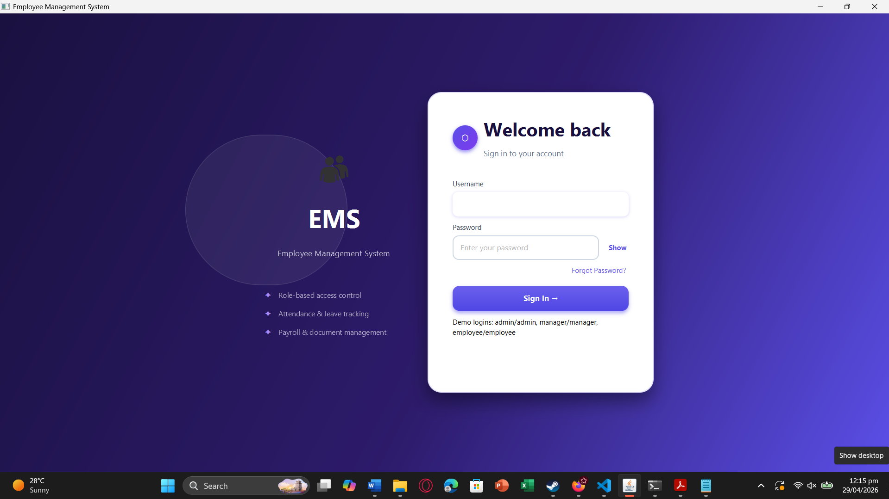
Figure 1: Login screen — user authentication and role-based sign-in.
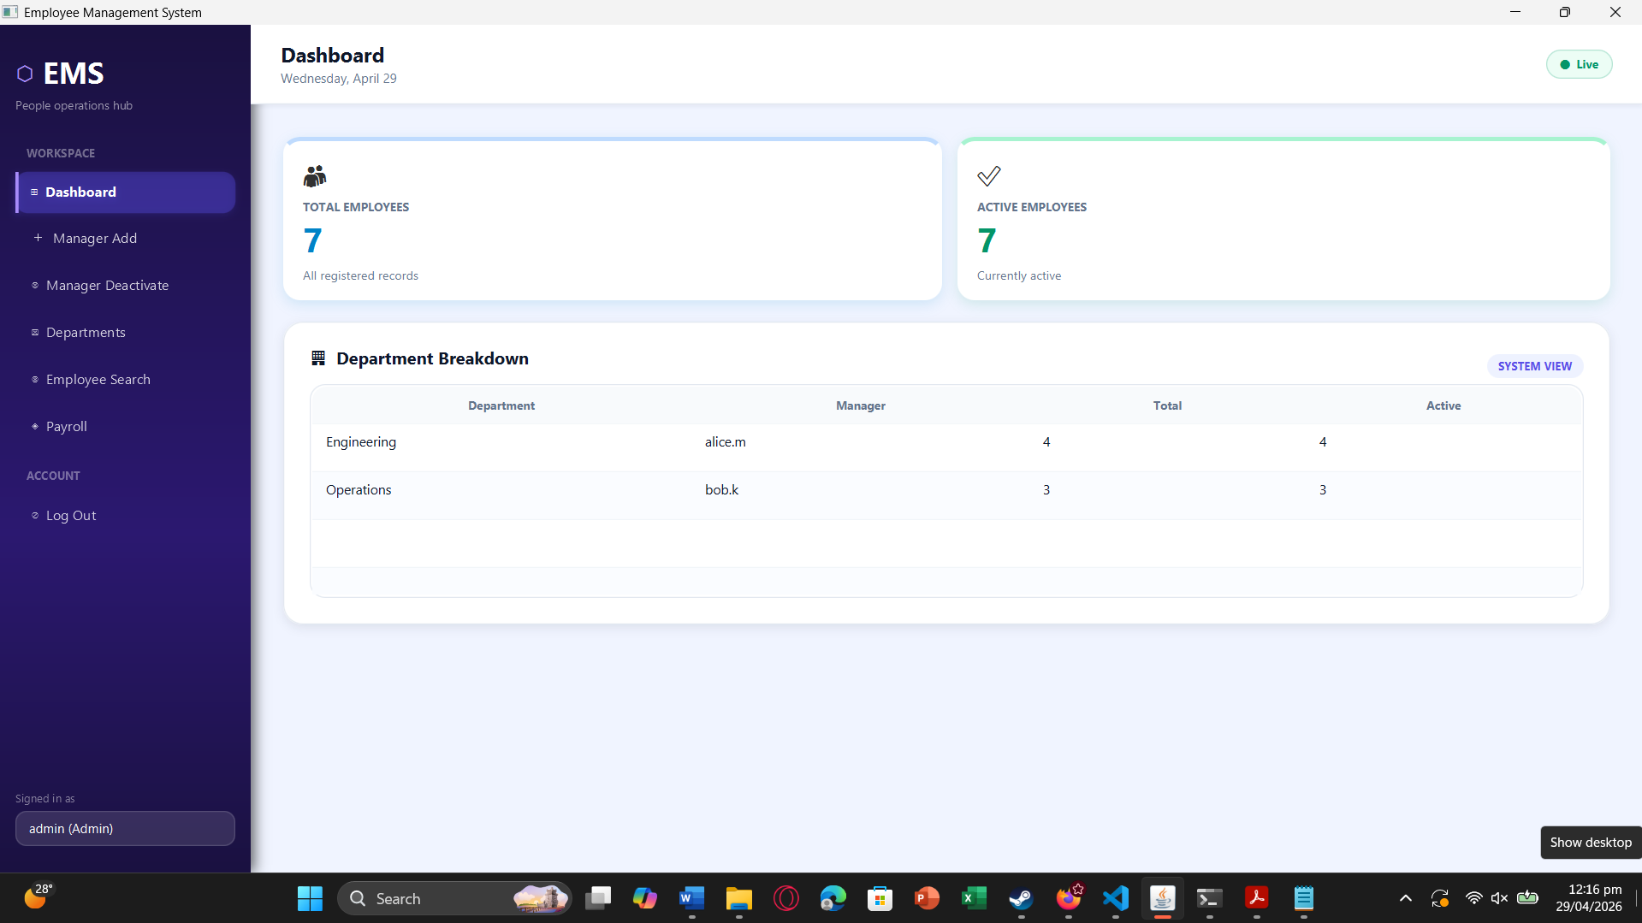
Figure 2: Admin view — department creation and manager account management.
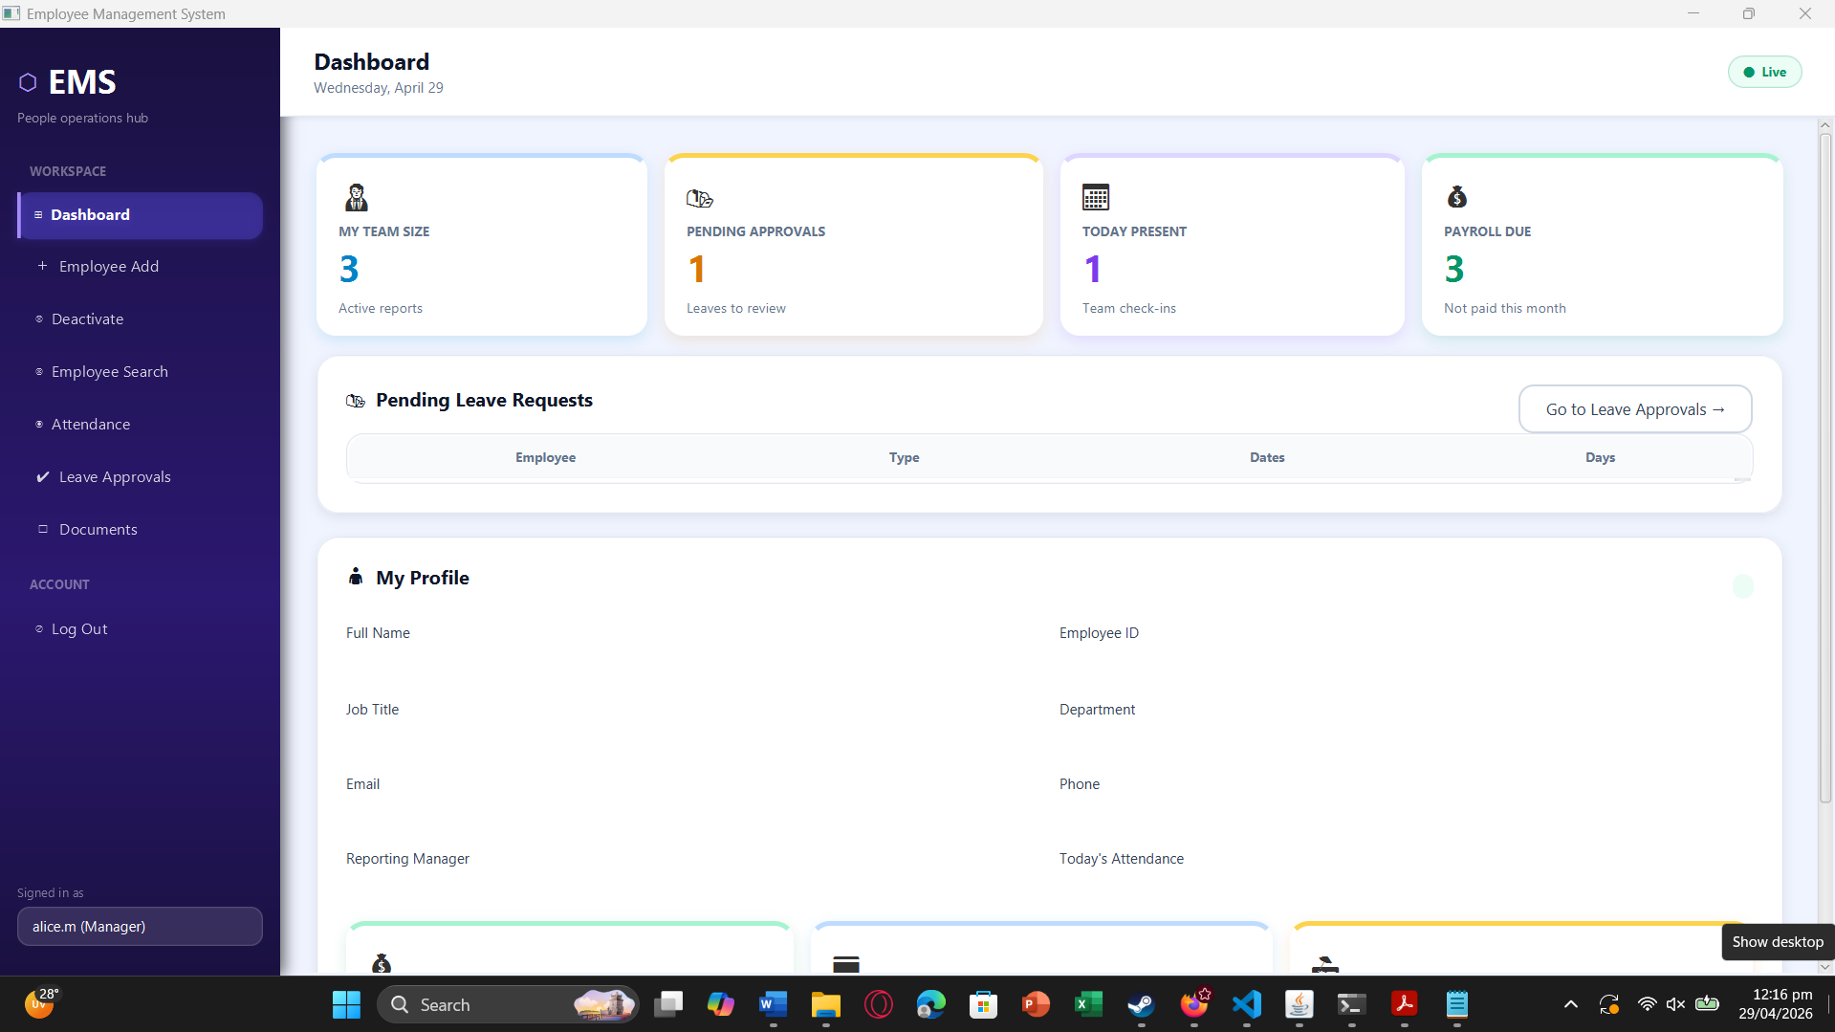
Figure 3: Manager view — employee add and deactivation request workflow.

10.2 Sprint 2 — Leave, Attendance & Search

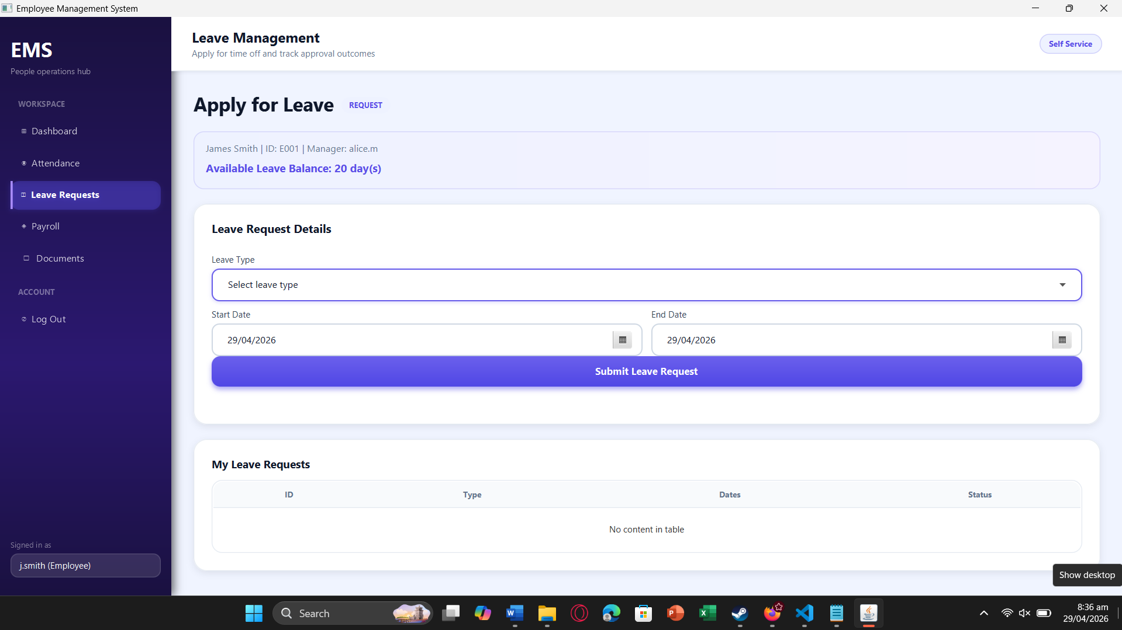
Figure 4: Leave application screen — employee submits a leave request.
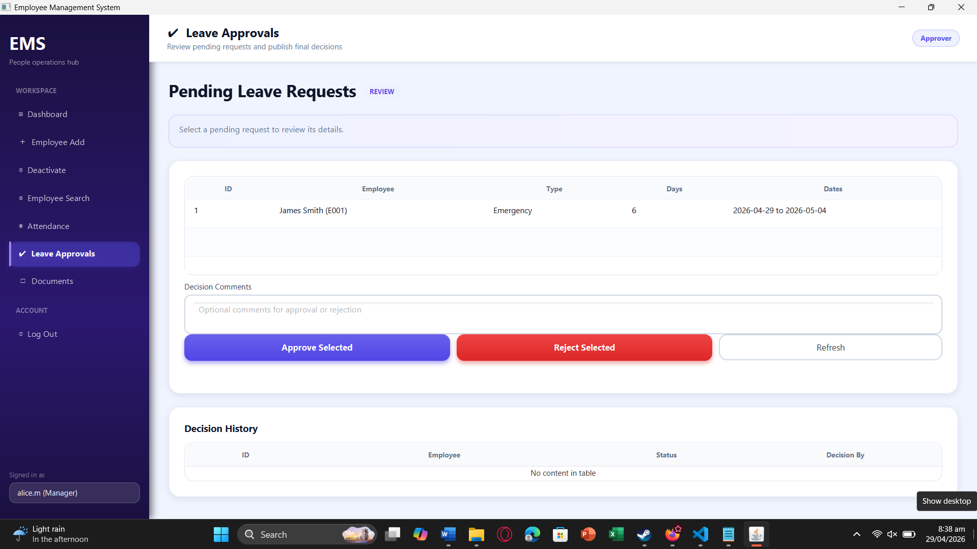
Figure 5: Leave approvals screen — manager reviews and processes leave requests.
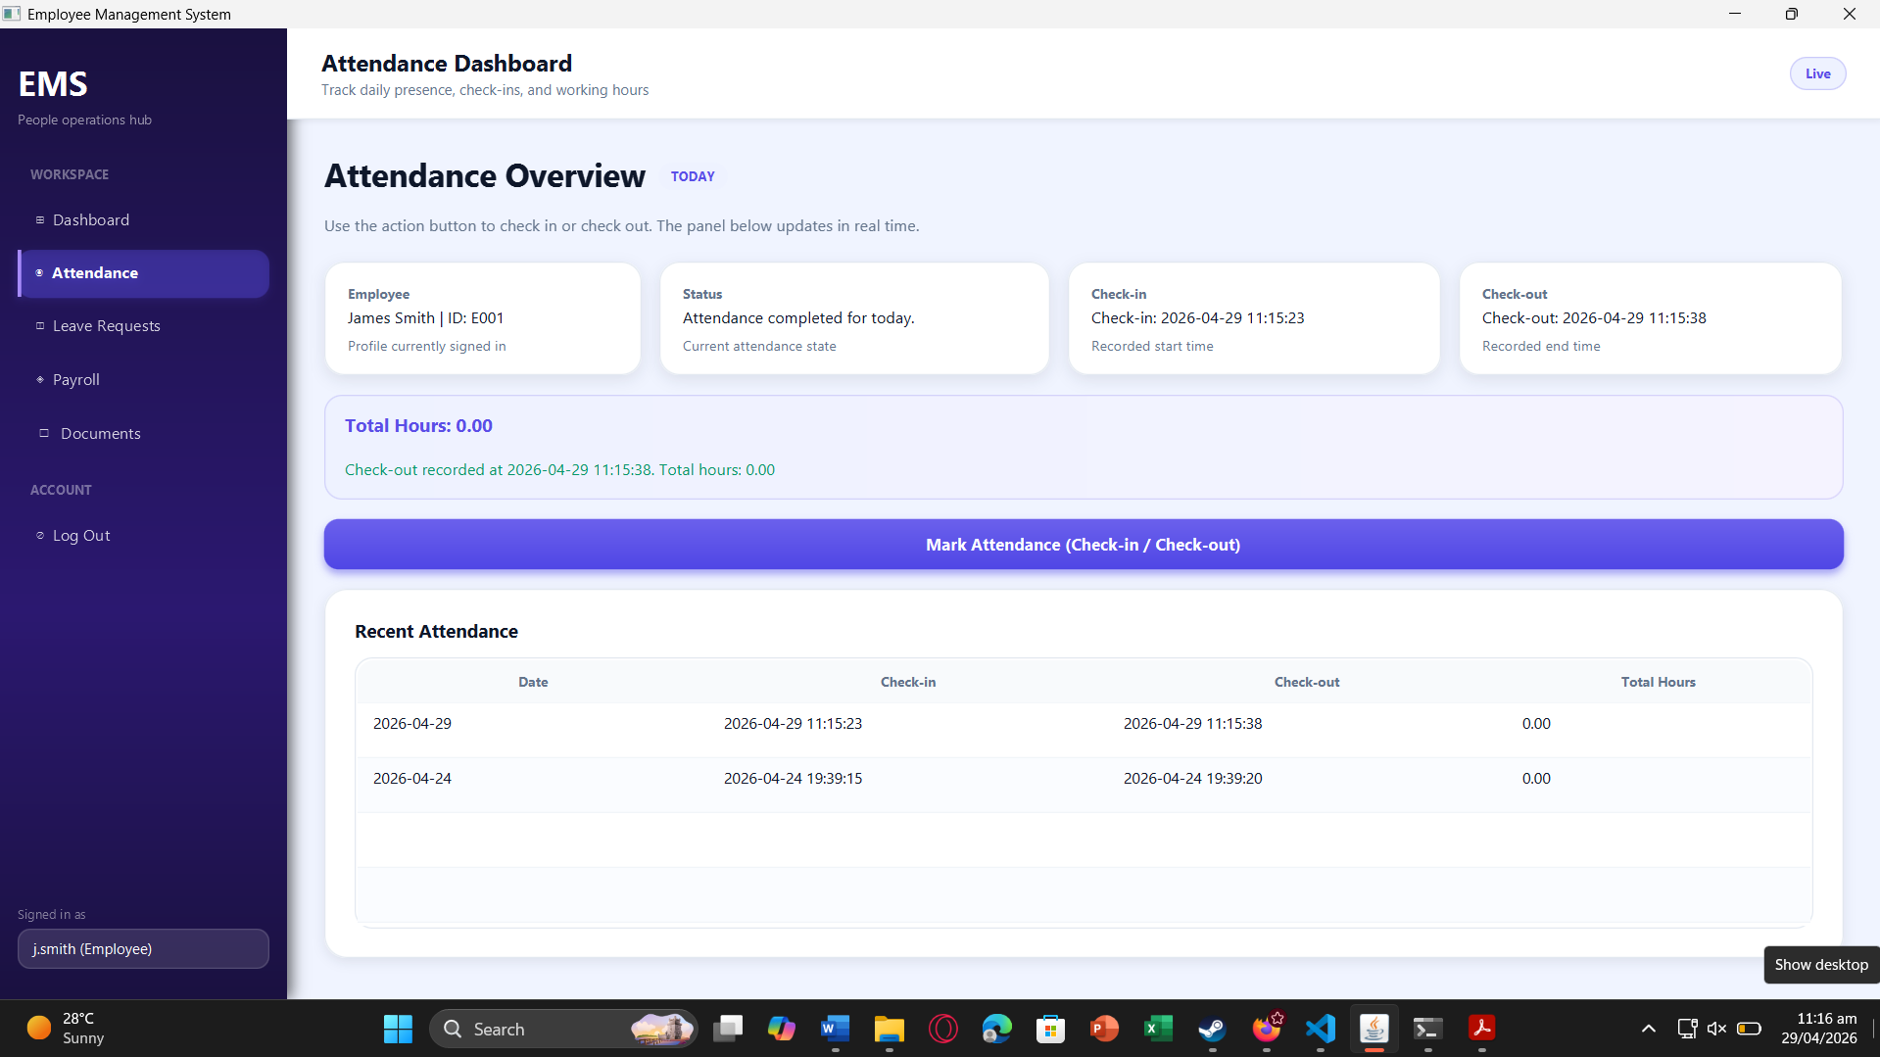
Figure 6: Attendance screen — employee marks check-in/check-out and views recent history.
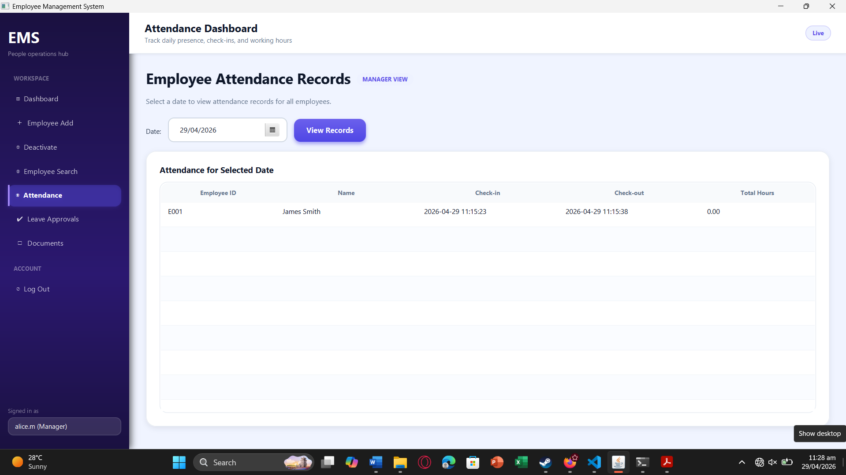
Figure 7: Team attendance screen — manager views team daily attendance for monitoring punctuality.
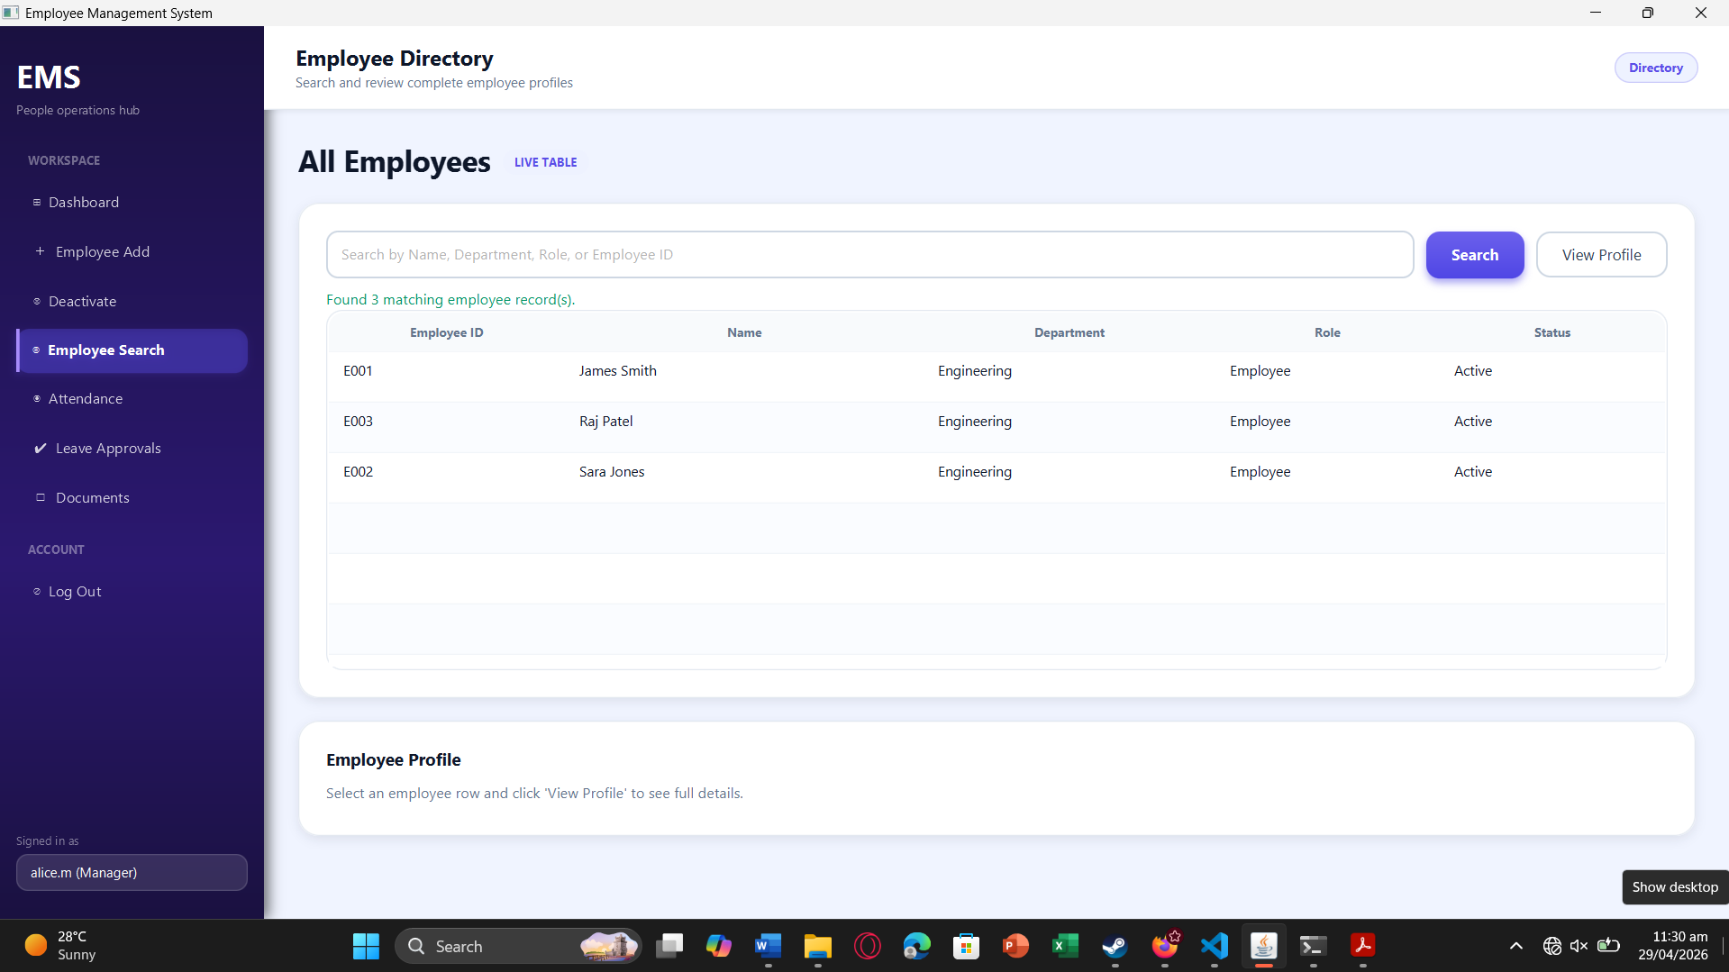
Figure 8: Employee search screen — manager searches employees within allowed scope.

10.3 Sprint 3 — Payroll, Documents & Dashboards

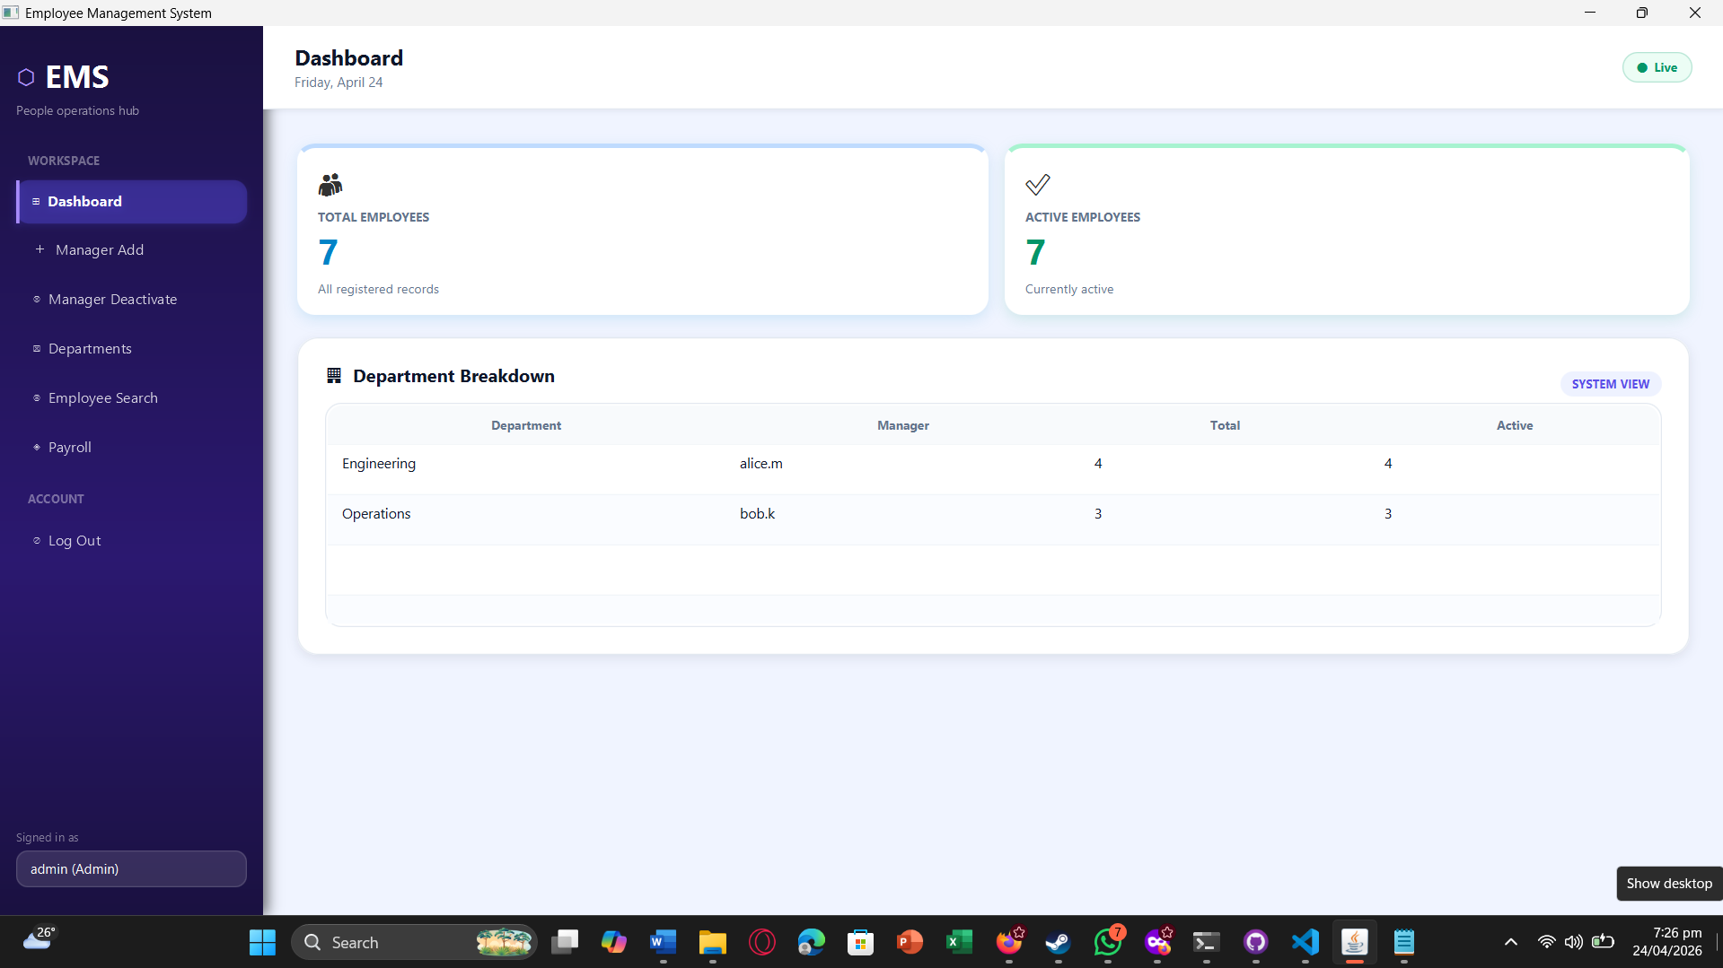
Figure 9: Admin Dashboard — organization-wide department breakdown with manager assignments displayed for strategic monitoring.
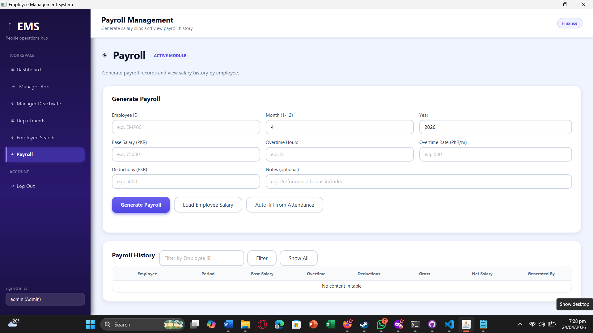
Figure 10: Payroll Generation — administrator generates payroll using employee period inputs, salary components, and validation checks.
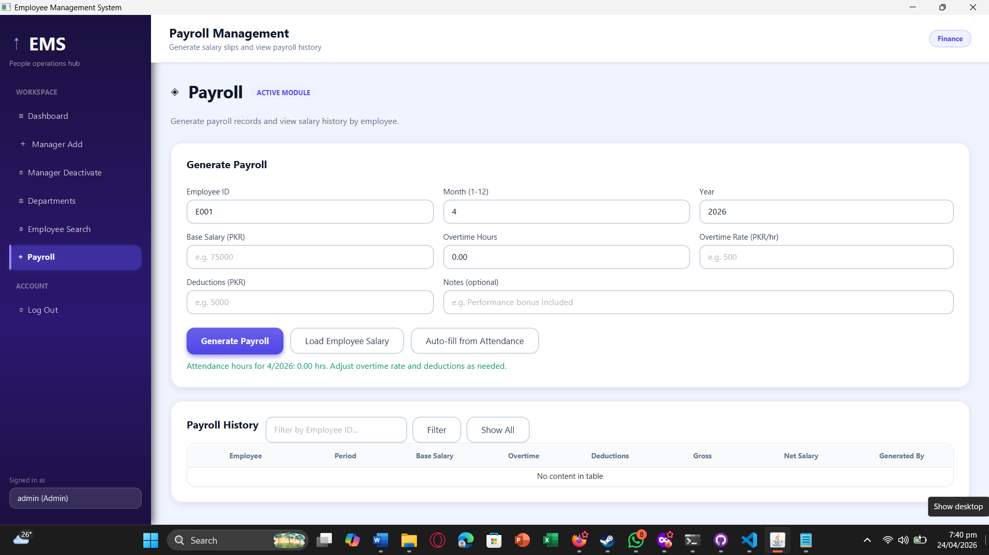
Figure 11: Department Deletion — administrator deletes a department only when no active employees are assigned, enforcing structural consistency.
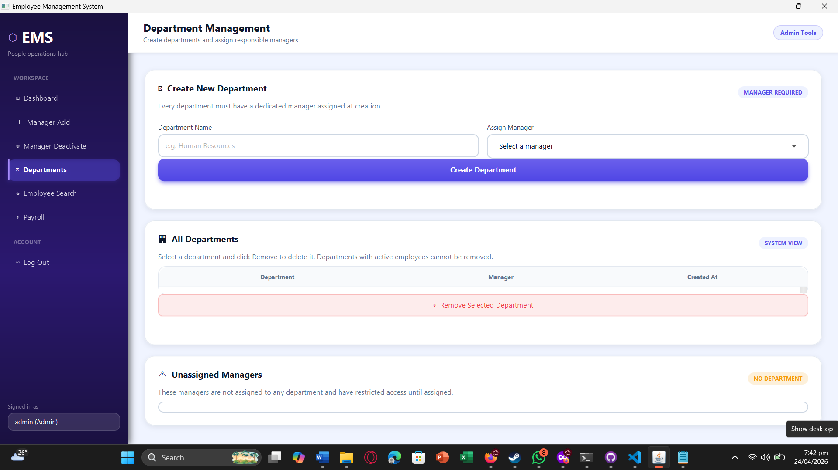
Figure 12: Payroll Auto-Fill — attendance-based hour totals are auto-filled to improve payroll accuracy and reduce manual entry.
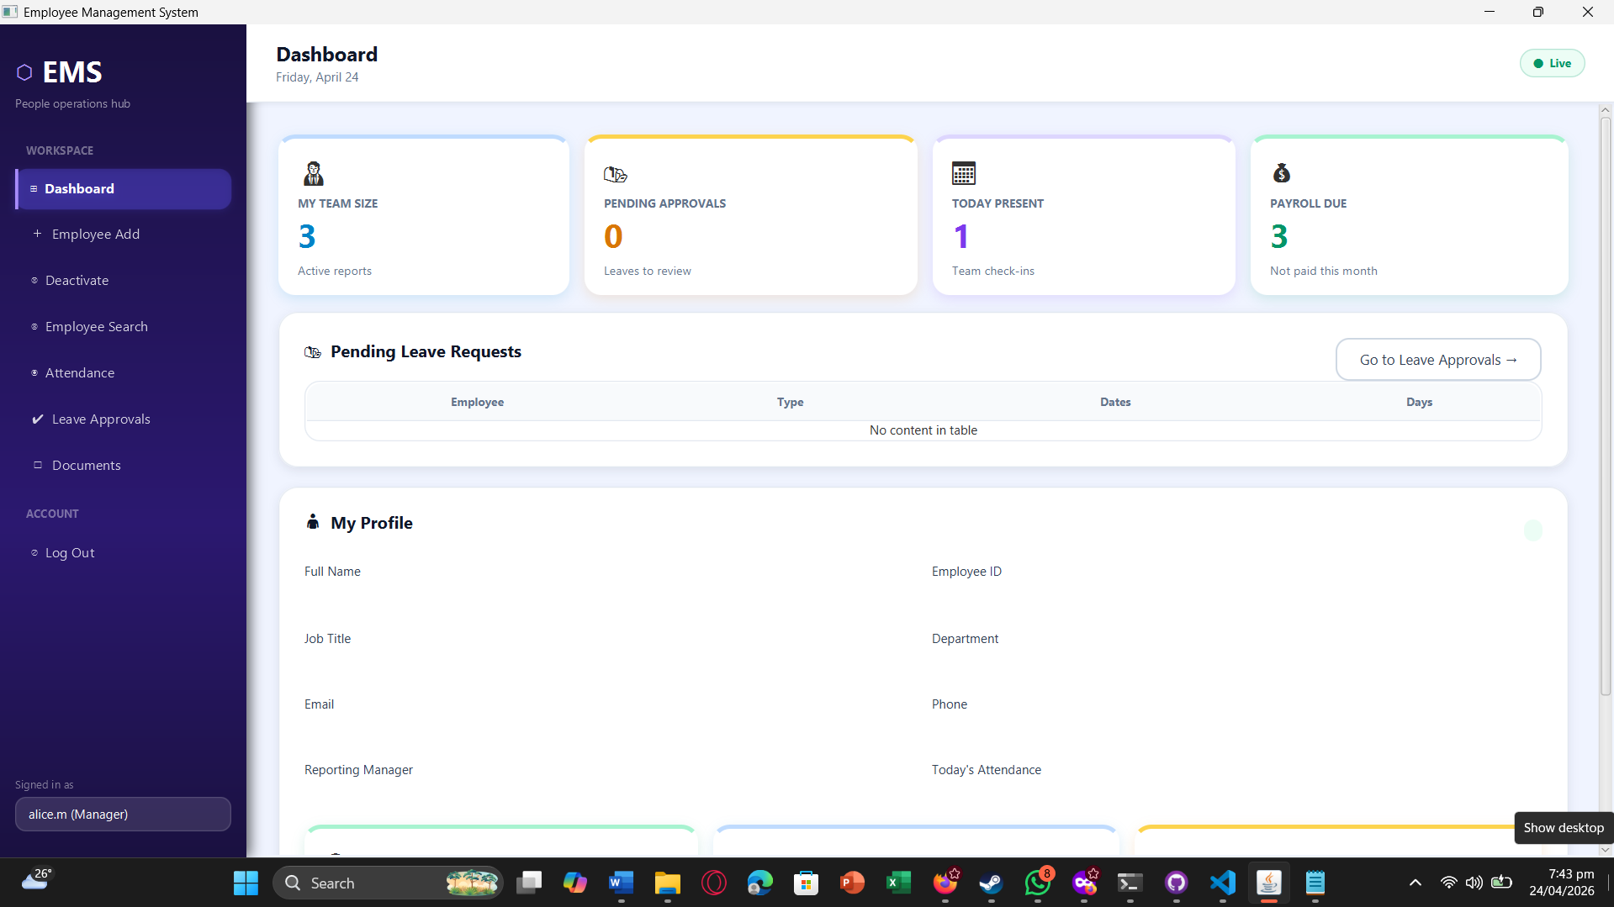
Figure 13: Manager Dashboard — department-scoped KPIs show team size, pending approvals, attendance status, and payroll due indicators.
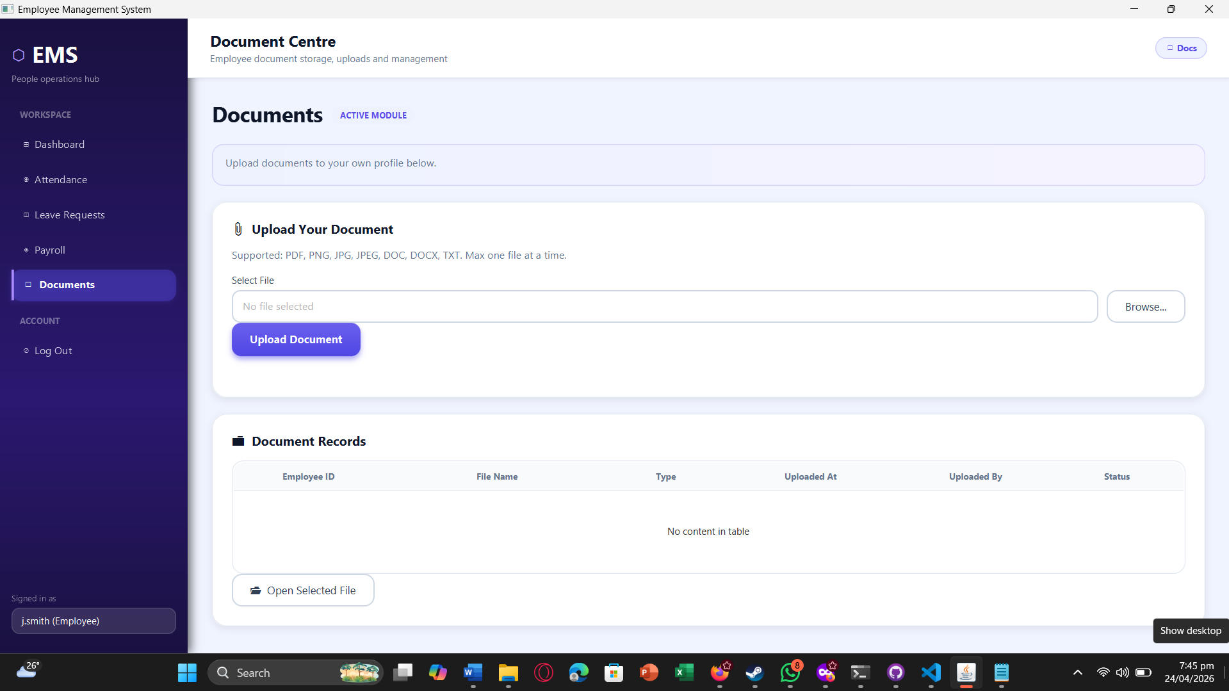
Figure 14: Document Upload — employee uploads a supported document to their own profile with default Pending status.
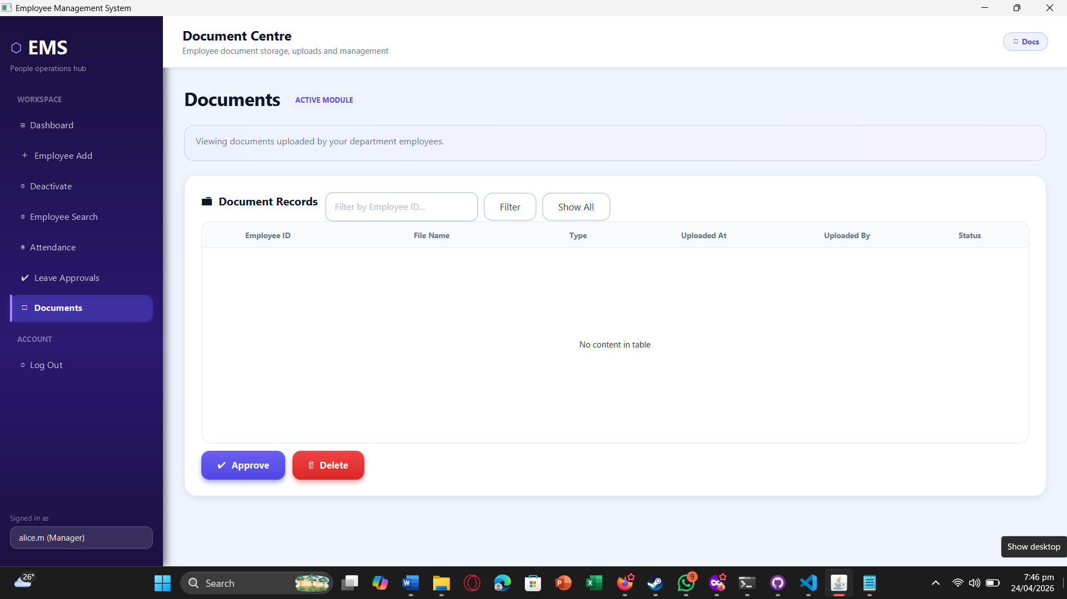
Figure 15: Document Approval/Deletion — manager reviews department documents and performs approve or delete actions based on verification.
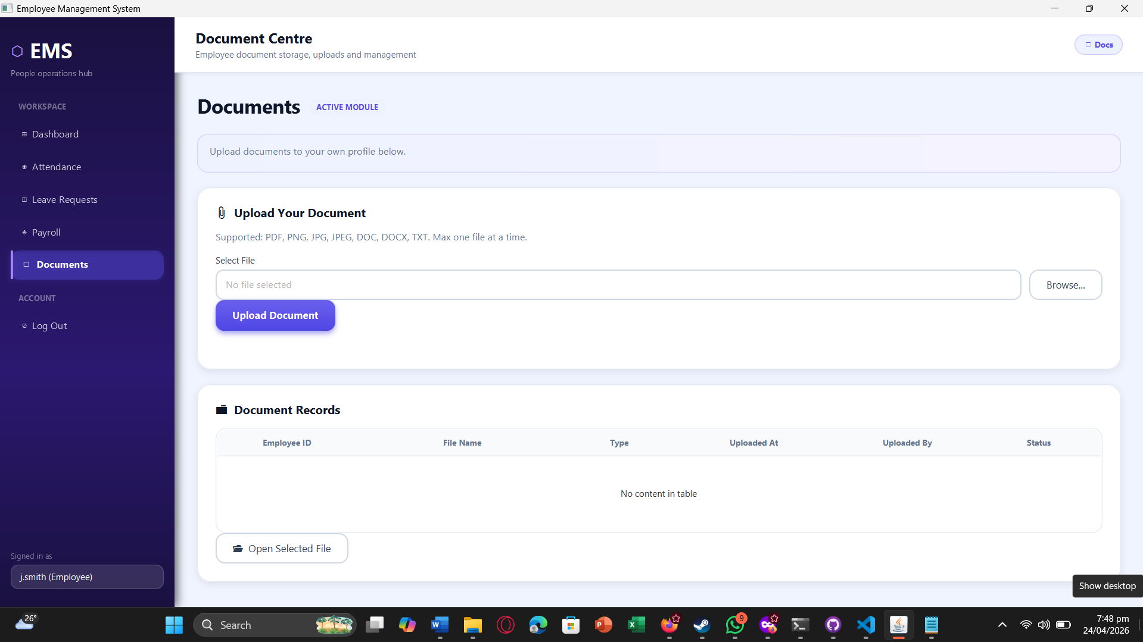
Figure 16: Employee Payroll View — employee can view only their own payroll history with role-based access restrictions applied.
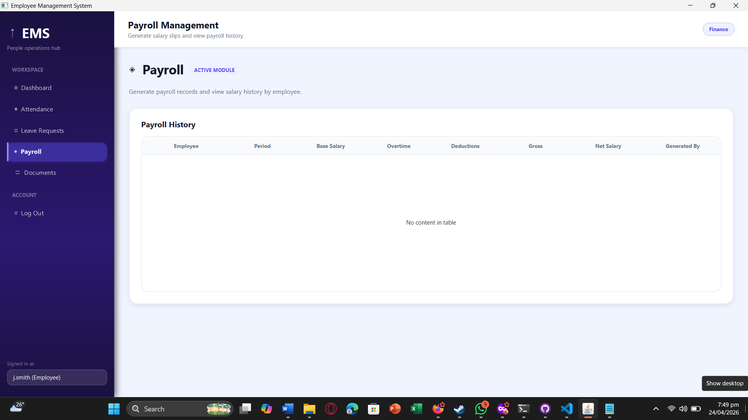
Figure 17: Document Open/View — employee opens an uploaded document through the system using the default OS file handler.

11. Work Division
Team Member | Sprint 1 | Sprint 2 | Sprint 3
Muhammad Faheem | Sprint planning, database schema, authentication system, AppSession and RBAC framework, BaseController. | Leave management service and approval workflow logic. Leave balance deduction and request handling. | Payroll service and payroll controller workflow. Attendance-to-payroll auto-fill integration. Sprint planning and integration support.
Irtaza Kazmi | Employee CRUD repository logic, department management logic, DepartmentRepository, deactivation workflow. | Attendance service implementation. Employee search scoping and related repository logic. | Document service and document controller implementation. Department-scoped document queries and document status handling. Department deletion flow implementation support.
Humayun Bilal | JavaFX FXML layouts, CSS design system, sidebar navigation, login screen UI. | UI for leave application, leave approvals, attendance, and employee search screens. Layout and interface adjustments for Sprint 2. | Dashboard UI and role-specific dashboard behavior. Payroll/document screen UI refinement. Testing execution, bug tracking, and quality-report preparation.

12. Final System Summary
The final EMS product combines Sprint 1 foundations (authentication, RBAC, employee lifecycle, departments), Sprint 2 operational workflows (leave, attendance, scoped search), and Sprint 3 completion modules (payroll, documents, dashboards, department deletion) into one integrated business system. The final system enforces a clear three-role hierarchy, protects role boundaries, centralizes employee operations, and delivers both operational automation and management visibility in a single desktop application.

